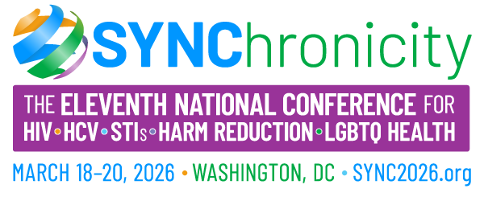
[DATE]
Dear [NAME],
I am writing to request approval to attend SYNChronicity 2026 (SYNC 2026), the 11th Annual National Conference for HIV, HCV, STI, Harm Reduction, and LGBTQ Health, organized by HealthHIV, HealthHCV, and the National Coalition on LGBT Health. The conference will be held March 16–20, 2026 at the Renaissance Arlington Capital View Hotel in Arlington, VA.
SYNC is recognized as the original conference driving a syndemic approach to health. Guided by the theme “Forward in Synchronicity,” this year’s conference represents an unparalleled opportunity to connect with healthcare providers, policymakers, community leaders, and organizations nationwide who are addressing the most pressing health challenges.
Highlights of SYNC 2026 include:
- Pre-conference institutes and training designed to address current health topics and strengthen professional development.
- Dynamic plenary sessions on strategies to end epidemics, financial sustainability in public health, public-private partnerships, consumer-provider collaboration for health equity, and synchronized efforts among government agencies.
- Specialized track sessions covering transgender health, aging with HIV, clinical practices, fiscal health, preventive care, and population-specific health tracks addressing MSM of color, Black women, and youth.
The registration fee of $260 (Early Bird rate through December 31, 2025) includes full access to the conference program, exhibitors/vendors, lunches, and free continuing education credits. The details can be viewed at SYNC Conference.
Attending SYNC 2026 will allow me to:
- Gain novel insights to apply directly in our work.
- Renew my inspiration and dedication to advancing health equity.
- Strengthen my confidence in our ability to navigate today’s healthcare challenges.
- Build new professional connections and collaboration opportunities.
Most importantly, SYNC will position me—and our organization—“Forward in Synchronicity” with others committed to health, equity, and change.
Thank you for considering my request. I greatly appreciate your support and approval to attend this impactful event.
Sincerely,

